**Hotel Management**

Mini-Project Report submitted in partial fulfilment of the requirements of the degree of Bachelor of Engineering by

Shreyas Patil 38

Shantanu Pawar 41

Raju Prajapati 43



Department of Computer Engineering

St. John College of Engineering and Management

University of Mumbai

Guide: Sankusu Sharma

2017-2018

# Abstract

This project helps to place an order as per the wish of the customer and what would be the total of the feeded order including the taxes on the food. Also this program is easy to use, its implementation is basic to understand and the execution is fast. This program can be used by both the client or the person at the counter. You just have to enter the number of items you need of the particular type. used by both the client or the person at the counter. This project also helps in hotel booking. Via this project you can do hotel booking at well as Restaurant Snacks Billing.

**Programming Environment**

1. tkinter

The Tkinter module (“Tk interface”) is the standard Python interface to the Tk GUI toolkit. Both Tk and Tkinter are available on most Unix platforms, as well as on Windows systems. (Tk itself is not part of Python; it is maintained at Active State.)

1. IDLE

For testing and debugging a program we have used IDLE i.e (Integrated development environment) as an python editor.

1. Microsoft Office 2016

All the project documents and this report were prepared using Microsoft Office 2016.

# Program

from tkinter import*

import os

import random

root=Tk() #creating a window

root.geometry("2000x4000") #window geometry

root.title("Restaurant Management System") #window title

#=============== Background Image ===============

C = Canvas(root, bg="blue")

fname = PhotoImage(file = "img5.png")

background_lbl = Label(root, image=fname)

background_lbl.place(x=0, y=0, relwidth=1, relheight=1)

C.grid()

def qParse():

creds = 'tempfile.txt' # This just sets the variable creds to 'tempfile.temp'

#================= Login Logic ======================

def Signup(): #function for signing up

global pwordE #globals variables

global nameE

global r1

r1 = Toplevel(root) #makes a child window

r1.title('Login')

intruction = Label(r1, text='Please Enter new Credidentials\n').grid(row=0, column=0, sticky=E)

nameL = Label(r1, text='New Username: ').grid(row=1, column=0, sticky=W) #uses Username as text

pwordL = Label(r1, text='New Password: ').grid(row=2, column=0, sticky=W)

nameE = Entry(r1)

nameE.grid(row=1, column=1)

pwordE = Entry(r1, show='*')

pwordE.grid(row=2, column=1) #difference 'show="*"'replace the text with *, like a password box

signupButton = Button(r1, text='Signup', command=FSSignup).grid(columnspan=2, sticky=W)

r1.mainloop()

def FSSignup():

with open(creds, 'w') as f: #creates a document

f.write(nameE.get()) #storing the input

f.write('\n') #splits the line

f.write(pwordE.get())

f.close() #closes the file

r1.destroy()

Login() #calling Login Function

def Login():

global nameEL

global pwordEL

global r2

r2 = Toplevel(root)

r2.title('Login')

intruction = Label(r2, text='Please Login\n').grid(sticky=E)

nameL = Label(r2, text='Username: ').grid(row=1, sticky=W)

pwordL = Label(r2, text='Password: ').grid(row=2, sticky=W)

nameEL = Entry(r2)

nameEL.grid(row=1, column=1)

pwordEL = Entry(r2, show='*')

pwordEL.grid(row=2, column=1)

loginB = Button(r2, text='Login', command=CheckLogin).grid(columnspan=2, sticky=W)

rmuser = Button(r2, text='Delete User', fg='red', command=DelUser).grid(columnspan=2, sticky=W)

r2.mainloop()

def CheckLogin():

with open(creds) as f:

data = f.readlines() #taking the entire document & putting it into the data variable

uname = data[0].rstrip() #data[0], 0 is the first line, 1 is the second and so on.

pword = data[1].rstrip() #removing the inputted new line

##------------------------ Hotel Management Coding --------------------------

if nameEL.get() == uname and pwordEL.get() == pword: #checks if entered data is correct

ro = Toplevel(r2) # Opens new window

ro.title('Hotel Bookings')

ro.geometry('2000x4000') # Makes the window a certain size

#-------------- Background Image --------------------

C1 = Canvas(ro, bg="blue")

filname = PhotoImage(file = "img2.png")

background_lab = Label(ro, image=filname)

background_lab.place(x=0, y=0, relwidth=1, relheight=1)

C1.grid()

#------------- Labels --------------------

lab1 = Label(ro, text="First Name: ", font=('arial',20,'bold'), fg="white",bg= "brown",bd=10,anchor='w').grid(row=0,column=0)

lab2 = Label(ro, text="Middle Name: ", font=('arial',20,'bold'), fg="white",bg= "brown",bd=10,anchor='w').grid(row=1,column=0)

lab3 = Label(ro, text="Last Name: ", font=('arial',20,'bold'), fg="white",bg= "brown",bd=10,anchor='w').grid(row=2,column=0)

lab4 = Label(ro, text="Type: ", font=('arial',20,'bold'), fg="white", bg= "brown", bd=10,anchor='w').grid(row=3,column=0)

lab5 = Label(ro, text="Location: ", font=('arial',20,'bold'), fg="white", bg= "brown", bd=10,anchor='w').grid(row=4,column=0)

#---------------- Entries -------------------- ( These now puts a text box waiting for input )

ent1 = Entry(ro, font=('arial',16,'bold'), bd=10,insertwidth=4,bg="brown",justify='left').grid(row=0, column=1)

ent2 = Entry(ro, font=('arial',16,'bold'), bd=10,insertwidth=4,bg="brown",justify='left').grid(row=1, column=1)

ent3 = Entry(ro, font=('arial',16,'bold'), bd=10,insertwidth=4,bg="brown",justify='left').grid(row=2, column=1)

def lqExit():

ro.destroy()

def lplace(place):

roots=Toplevel(ro)

roots.title("Bookings in " + place + " Branch")

roots.geometry("2000x4000")

C2 = Canvas(roots, bg="blue")

filename = PhotoImage(file = "img3.png")

background_label = Label(roots, image=filename)

background_label.place(x=0, y=0, relwidth=1, relheight=1)

C2.grid()

func(roots)

def func(roots):

def qTotal():

if (Days.get() == ""):

CoDays = 0

else:

CoDays = int(Days.get())

if (Per.get() == ""):

CoPer = 0

else:

CoPer = int(Per.get())

if (Rooms.get() == ""):

CoRooms = 0

else:

CoRooms = int(Rooms.get())

if (e1.get() == ""):

fDay = 0

else:

fDay = int(e1.get())

if (e2.get() == ""):

fMonth = 0

else:

fMonth = int(e2.get())

if (e3.get() == ""):

fYear = 0

else:

fYear = int(e3.get())

if (e4.get() == ""):

tDay = 0

else:

tDay = int(e4.get())

if (e5.get() == ""):

tMonth = 0

else:

tMonth = int(e5.get())

if (e6.get() == ""):

tYear = 0

else:

tYear = int(e6.get())

if (Total.get() == ""):

CoTotal = 0

#--------------------------- Costs Logic -------------------------

CostofDays = CoDays * 700

CostofPer = CoPer * 300

CostofRooms = CoRooms * 1000

TotalCost = "Rs.", str('%.2f' % (CostofDays + CostofRooms))

Total.set(TotalCost)

def qExit():

roots.destroy()

def Reset():

Days.set("")

Per.set("")

Rooms.set("")

e1.set("")

e2.set("")

e3.set("")

e4.set("")

e5.set("")

e6.set("")

Total.set("")

#-------------------------- Assignments -----------------------------

Days = StringVar()

Per = StringVar()

Rooms = StringVar()

e1 = StringVar()

e2 = StringVar()

e3 = StringVar()

e4 = StringVar()

e5 = StringVar()

e6 = StringVar()

Total = StringVar()

#---------------------------- Labels & Grid -----------------------------

lblDays = Label(roots, font=('arial', 20, 'bold'), text="Number of days need room for---", bd=16, fg="blue", anchor="w").grid(row=0, column=0)

txtDays = Entry(roots, font=('arial', 16, 'bold'), textvariable=Days, bd=10, insertwidth=4, bg="cyan", justify='right').grid(row=0, column=2)

lblPer = Label(roots, font=('arial', 20, 'bold'), text="Number of Persons are staying---", bd=16, fg="blue", anchor="w").grid(row=1, column=0)

txtPer = Entry(roots, font=('arial', 16, 'bold'), textvariable=Per, bd=10, insertwidth=4, bg="cyan", justify='right').grid(row=1, column=2)

lblRooms = Label(roots, font=('arial', 20, 'bold'), text="Number of rooms needed---", bd=16, fg="blue", anchor="w").grid(row=2, column=0)

txtRooms = Entry(roots, font=('arial', 16, 'bold'), textvariable=Rooms, bd=10, insertwidth=4, bg="cyan", justify='right').grid(row=2, column=2)

lblFromDate = Label(roots, text="Room needed From Date---", font=('arial', 20, 'bold'), fg="blue", bd=16, anchor='w').grid(row=3, column=0)

txtday = Entry(roots, font=('arial', 16, 'bold'), textvariable=e1, bd=8, insertwidth=2, bg="cyan", justify='right').grid(row=3, column=1)

txtmonth = Entry(roots, font=('arial', 16, 'bold'), textvariable=e2, bd=8, insertwidth=2, bg="cyan", justify='right').grid(row=3, column=2)

txtyear = Entry(roots, font=('arial', 16, 'bold'), textvariable=e3, bd=8, insertwidth=2, bg="cyan", justify='right').grid(row=3, column=3)

lblTilDate = Label(roots, font=('arial', 20, 'bold'), text="Room needed To Date---(dd,mm,yy)", bd=16, fg="blue", anchor="w").grid(row=4, column=0)

txtday = Entry(roots, font=('arial', 16, 'bold'), textvariable=e4, bd=8, insertwidth=2, bg="cyan", justify='right').grid(row=4, column=1)

txtmonth = Entry(roots, font=('arial', 16, 'bold'), textvariable=e5, bd=8, insertwidth=2, bg="cyan", justify='right').grid(row=4, column=2)

txtyear = Entry(roots, font=('arial', 16, 'bold'), textvariable=e6, bd=8, insertwidth=2, bg="cyan", justify='right').grid(row=4, column=3)

lblTotalCost = Label(roots, font=('arial', 20, 'bold'), text="Total Cost ---", bd=16, fg="purple", anchor="w").grid(rows=5, column=0)

txtTotalCost = Entry(roots, font=('arial', 16, 'bold'), textvariable=Total, bd=10, insertwidth=4, bg="cyan", justify='right').grid(row=5, column=2)

# ------------------------------ Buttons ---------------------------------

btnTot = Button(roots, padx=16, pady=8, bd=16, fg="red", font=('arial', 16, 'bold'), width=10, text="Total", bg="yellow", command=qTotal).grid(row=7, column=1

btnRst = Button(roots, padx=16, pady=8, bd=16, fg="red", font=('arial', 16, 'bold'), width=10, text="Reset", bg="yellow", command=Reset).grid(row=7, column=2)

btnExt = Button(roots, padx=16, pady=8, bd=16, fg="red", font=('arial', 16, 'bold'), width=10, text="Exit", bg="yellow", command=qExit).grid(row=7, column=3)

#-------------- Radio Button --------------------

var_chk = IntVar()

rd1 = Radiobutton(ro, text="A\C", variable=var_chk, value=1, bg="brown").grid(row=3, column=1, sticky=W)

rd2 = Radiobutton(ro, text="NON A\C", variable=var_chk, value=2, bg="brown").grid(row=3, column=1, sticky=E)

#--------------- Buttons --------------------

btnDah = Button(ro, padx=16, pady=8, bd=16, fg="red", font=('arial', 16, 'bold'), width=10, text="Dahanu", bg="orange", command=lambda: lplace("Dahanu")).grid(row=4, column=1)

btnBoi = Button(ro, padx=16, pady=8, bd=16, fg="red", font=('arial', 16, 'bold'), width=10, text="Boisar", bg="orange", command=lambda: lplace("Boisar")).grid(row=4, column=2)

btnPal = Button(ro, padx=16, pady=8, bd=16, fg="red", font=('arial', 16, 'bold'), width=10, text="Palghar", bg="orange", command=lambda: lplace("Palghar")).grid(row=4, column=3)

btnVir = Button(ro, padx=16, pady=8, bd=16, fg="red", font=('arial', 16, 'bold'), width=10, text="Virar", bg="orange", command=lambda: lplace("Virar")).grid(row=5, column=1)

btnBor = Button(ro, padx=16, pady=8, bd=16, fg="red", font=('arial', 16, 'bold'), width=10, text="Borivali", bg="orange", command=lambda: lplace("Borivali")).grid(row=5, column=2)

btnChu = Button(ro, padx=16, pady=8, bd=16, fg="red", font=('arial', 16, 'bold'), width=10, text="Churchgate", bg="orange", command=lambda: lplace("Churchgate")).grid(row=5, column=3)

btnEx = Button(ro, padx=16, pady=8, bd=16, fg="red", font=('arial', 16, 'bold'), width=10, text="Exit", bg="orange", command=lqExit).grid(row=6, column=2)

ro.mainloop()

else:

r = TopLevel(r2)

r.title('Login Issue')

r.geometry('500x500')

rlbl = Label(r, text='\n[!] Invalid Login')

rlbl.pack()

r.mainloop()

def DelUser():

os.remove(creds) #removes the file

r2.destroy()

Signup() #going back to the start!

if os.path.isfile(creds):

Login()

else:

Signup()

def Ref():

x=random.randint(10908,500876) #for a random value in rand

randomRef=str(x)

rand.set(randomRef)

if (ChickenBurger.get()==""):

CoChickenBurger=0

else:

CoChickenBurger=float(ChickenBurger.get())

if (Noodles.get()==""):

CoNoodles=0

else:

CoNoodles=float(Noodles.get())

if (Soup.get()==""):

CoSoup=0

else:

CoSoup=float(Soup.get())

if (Frankie.get()==""):

CoFrankie=0

else:

CoFrankie=float(Frankie.get())

if (Sandwich.get()==""):

CoSandwich=0

else:

CoSandwich=float(Sandwich.get())

if (Drinks.get()==""):

CoD=0

else:

CoD=float(Drinks.get())

#============== Cost Logic ====================

CostofChickenBurger =CoChickenBurger * 45

CostofDrinks=CoD * 80

CostofNoodles = CoNoodles* 80

CostofSoup = CoSoup * 80

CostFrankie = CoFrankie* 60

CostSandwich=CoSandwich * 50

CostofMeal= "Rs", str('%.2f' % (CostofChickenBurger+CostofDrinks+CostofNoodles+CostofSoup+CostFrankie+CostSandwich))

PayTax=((CostofChickenBurger+CostofDrinks+CostofNoodles+CostofSoup+CostFrankie+CostSandwich) * 0.2)

TotalCost=(CostofChickenBurger+CostofDrinks+CostofNoodles+CostofSoup+CostFrankie+CostSandwich)

Ser_Charge= ((CostofChickenBurger+CostofDrinks+CostofNoodles+CostofSoup+CostFrankie+CostSandwich)/99)

Service = "Rs", str ('%.2f' % Ser_Charge)

OverAllCost ="Rs", str ('%.2f' % (PayTax+TotalCost+Ser_Charge))

PaidTax= "Rs", str ('%.2f' % PayTax)

Service_Charge.set(Service)

Cost.set(CostofMeal)

Tax.set(PaidTax)

SubTotal.set(CostofMeal)

Total.set(OverAllCost)

def qExit():

root.destroy()

def Reset():

rand.set("")

ChickenBurger.set("")

Noodles.set("")

Soup.set("")

SubTotal.set("")

Total.set("")

Service_Charge.set("")

Drinks.set("")

Tax.set("")

Cost.set("")

Frankie.set("")

Sandwich.set("")

#================ Variables Assignments ================

rand = StringVar()

ChickenBurger=StringVar()

Noodles=StringVar()

Soup=StringVar()

SubTotal=StringVar()

Total=StringVar()

Service_Charge=StringVar()

Drinks=StringVar()

Tax=StringVar()

Cost=StringVar()

Frankie=StringVar()

Sandwich=StringVar()

#================= Restaraunt Info 1 =================

lblChickenBurger= Label(root, font=('arial', 16, 'bold'),text="Chicken Burger (Rs 45)",bd=16,fg="blue",anchor="w").grid(row=0, column=0)

txtChickenBurger=Entry(root, font=('arial',16,'bold'),textvariable=ChickenBurger,bd=10,insertwidth=4,bg="cyan",justify='right').grid(row=0,column=1)

lblNoodles= Label(root, font=('arial', 16, 'bold'),text="Noodles (Rs 80)",bd=16,fg="blue",anchor="w").grid(row=1, column=0)

txtNoodles=Entry(root, font=('arial',16,'bold'),textvariable=Noodles,bd=10,insertwidth=4,bg="cyan",justify='right').grid(row=1,column=1)

lblSoup= Label(root, font=('arial', 16, 'bold'),text="Soup (Rs 80)",bd=16,fg="blue",anchor="w").grid(row=2, column=0)

txtSoup=Entry(root, font=('arial',16,'bold'),textvariable=Soup,bd=10,insertwidth=4,bg="cyan",justify='right').grid(row=2,column=1)

lblFrankie= Label(root, font=('arial', 16, 'bold'),text="Frankie (Rs 60)",bd=16,fg="blue",anchor="w").grid(row=3, column=0)

txtFrankie=Entry(root, font=('arial',16,'bold'),textvariable=Frankie,bd=10,insertwidth=4,bg="cyan",justify='right').grid(row=3,column=1)

lblSandwich= Label(root, font=('arial', 16, 'bold'),text="Sandwich (Rs 50)",bd=16,fg="blue",anchor="w").grid(row=4, column=0)

txtSandwich=Entry(root, font=('arial',16,'bold'),textvariable=Sandwich,bd=10,insertwidth=4,bg="cyan",justify='right').grid(row=4,column=1)

lblDrinks= Label(root, font=('arial', 16, 'bold'),text="Drinks (Rs 80)",bd=16,fg="blue",anchor="w").grid(row=5, column=0)

txtDrinks=Entry(root, font=('arial',16,'bold'),textvariable=Drinks,bd=10,insertwidth=4,bg="cyan",justify='right').grid(row=5,column=1)

#=============== RESTAURANT INFO 2 ===============

lblReference= Label(root, font=('arial', 16,'bold'),text="Reference"

,bd=16,fg="blue",anchor="w").grid(row=0, column=2)

txtReference=Entry(root, font=('arial',16,'bold'),textvariable=rand,bd=10,insertwidth=4,bg="cyan",justify='right').grid(row=0,column=3)

lblCost= Label(root, font=('arial', 16, 'bold'),text="Cost of Meal",bd=16,fg="blue",anchor="w").grid(row=1, column=2)

txtCost=Entry(root,font=('arial',16,'bold'),textvariable=Cost,bd=10,insertwidth=4,bg="cyan",justify='right').grid(row=1,column=3)

lblService= Label(root, font=('arial', 16, 'bold'),text="Service Charge",bd=16,fg="blue",anchor="w").grid(row=2, column=2)

txtService=Entry(root, font=('arial',16,'bold'),textvariable=Service_Charge,bd=10,insertwidth=4,bg="cyan",justify='right').grid(row=2,column=3)

lblStateTax= Label(root, font=('arial', 16, 'bold'),text="GST",bd=16,fg="blue",anchor="w").grid(row=3, column=2)

txtStateTax=Entry(root, font=('arial',16,'bold'),textvariable=Tax,bd=10,insertwidth=4,bg="cyan",justify='right').grid(row=3,column=3)

lblSubTotal= Label(root, font=('arial', 16, 'bold'),text="Sub Total",bd=16,fg="blue",anchor="w").grid(row=4, column=2)

txtSubTotal=Entry(root, font=('arial',16,'bold'),textvariable=SubTotal,bd=10,insertwidth=4,bg="cyan",justify='right').grid(row=4,column=3)

lblTotalCost= Label(root, font=('arial', 16, 'bold'),text="Total Cost",bd=16,fg="blue",anchor="w").grid(row=5, column=2)

txtTotalCost=Entry(root, font=('arial',16,'bold'),textvariable=Total,bd=10,insertwidth=4,bg="cyan",justify='right').grid(row=5,column=3)

#================= Buttons ================

btnTotal=Button(root,padx=16,pady=8,bd=16,fg="red",font=('arial',16,'bold'),width=10,text="Total",bg="cyan",command=Ref).grid(row=7,column=1)

btnReset=Button(root,padx=16,pady=8,bd=16,fg="red",font=('arial',16,'bold'),width=10,text="Reset",bg="cyan",command=Reset).grid(row=7,column=2)

btnExit=Button(root,padx=16,pady=8,bd=16,fg="red",font=('arial',16,'bold'),width=10,text="Exit",bg="cyan",command=qExit).grid(row=7,column=3)

btnHM=Button(root,padx=16,pady=8,bd=16,fg="red",font=('arial',16,'bold'),width=15,text="Hotel Management",bg="yellow",command=qParse).grid(row=9,column=4)

root.mainloop()

**Output:-**

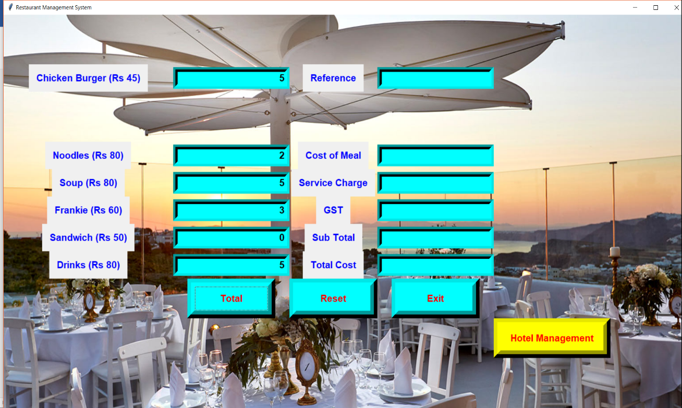

**Figure 1 -** After inputting the desired values in the 1st Billing Window.

**Figure 2 -** On pressing the Total Button and getting the following values.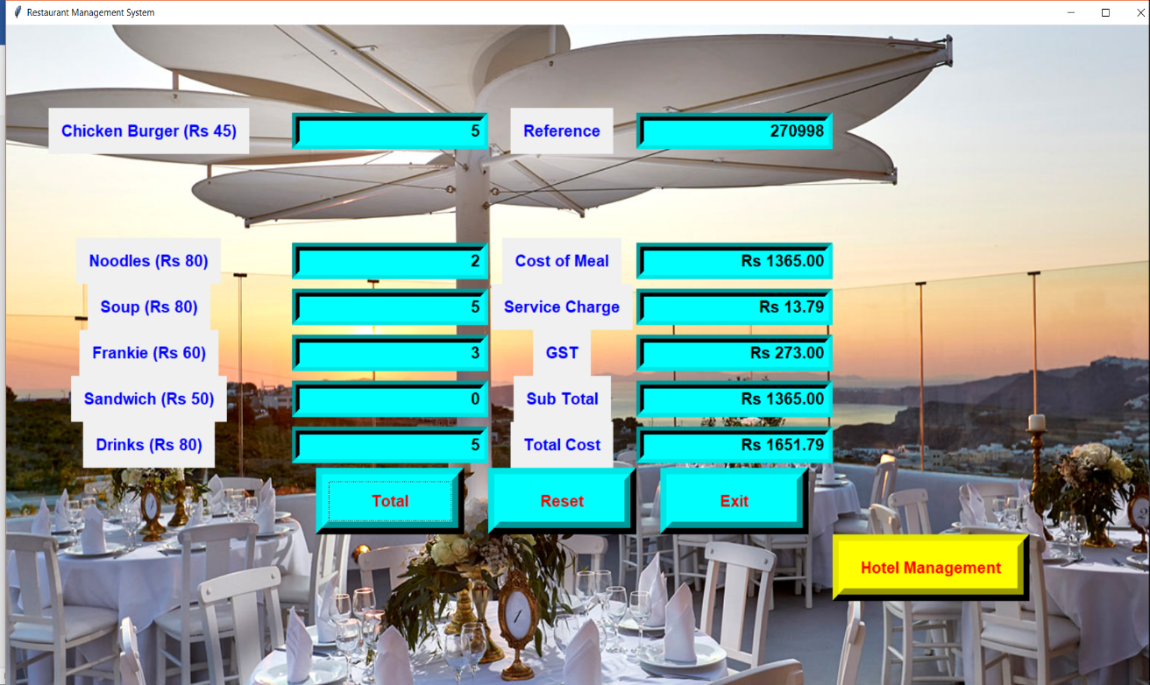

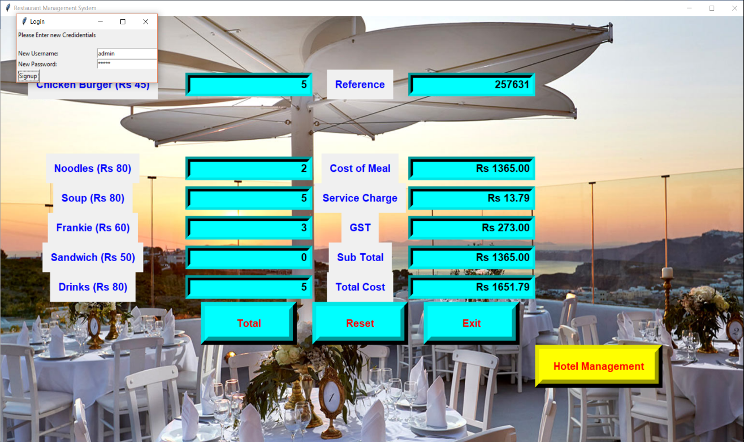

**Figure 3 -** On pressing the “Hotel Management” Tab for Hotel Booking Window we get a “Sign-up” window for a new user.

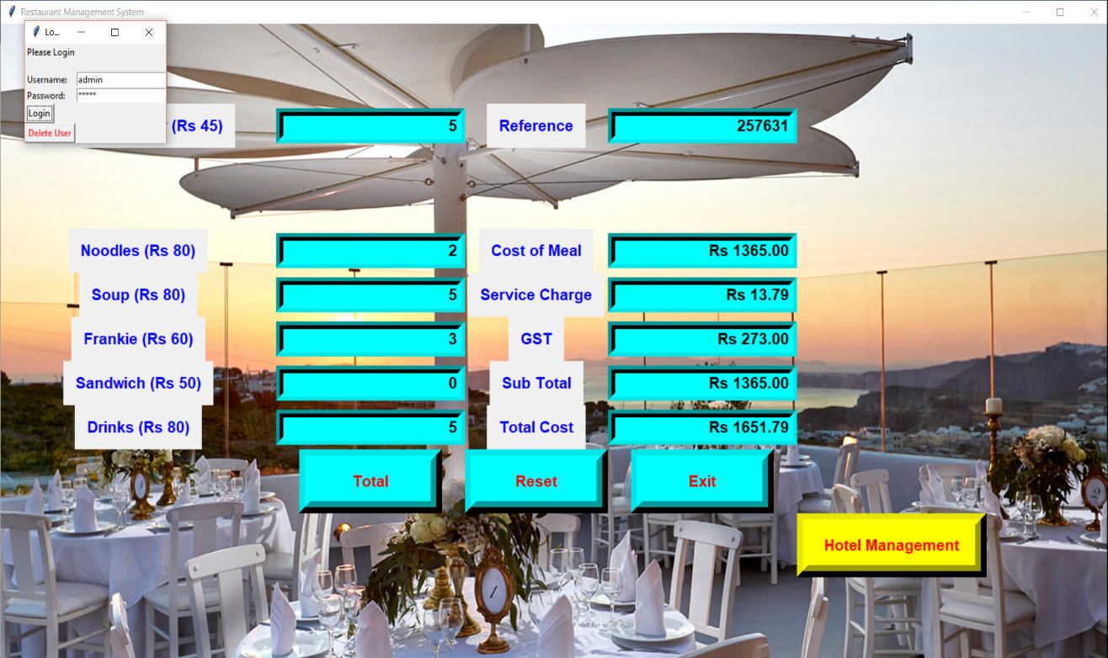

**Figure 4 -** On Signing up and Submitting the data we get a “Login Page”.

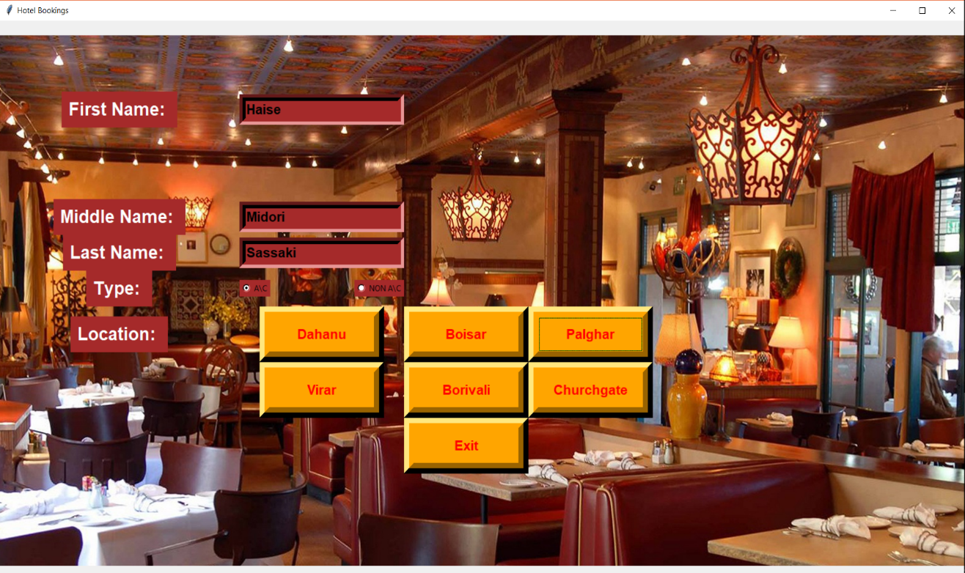

**Figure 5 -** On inputting correct inputted values in “Login Page”, we get 2nd window that is the “Hotel Booking” window. On putting inputting the desired values in 2nd Window.

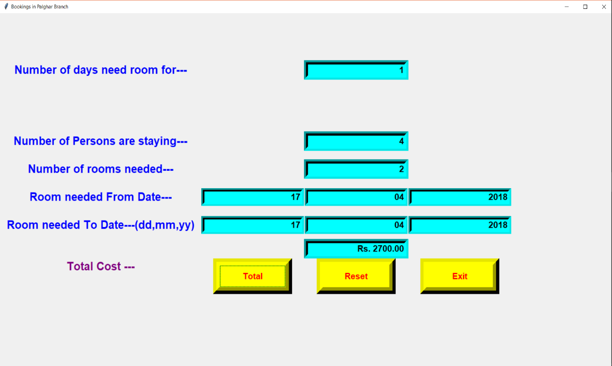 **Figure 6 -** After Selecting the desired location and inputting the values in it.

**Conclusion:**

Thus we have implemented a program to give total amount of a given order and to book a hotel room for a desired number of days using tkinter in python.